

**NATIONAL ECONOMIC CONSULTATIVE FORUM**

**MONTHLY ECONOMIC BULLETIN**

**OCTOBER 2024**

# Executive Summary

This bulletin focuses on economic developments for the month ending 31 October 2024 that include, World economic developments, international commodity prices, Zimbabwe Gross Domestic Product (GDP) growth updates, merchandise trade developments, exchange rate developments, inflation developments, monetary developments and stock market developments.

The global economic outlook for 2024 and 2025 signals a slowdown, with growth projected to decline from 3.3% in 2023 to 3.2% in 2024 and 2025, as outlined in the International Monetary Fund’s October 2024 World Economic Outlook (WEO). The deceleration is attributed to political uncertainties, adverse weather conditions, and geopolitical conflicts. For low-income developing countries, including Zimbabwe, growth prospects remain subdued due to limited fiscal space and delayed structural reforms, which constrain responses to energy and food crises.

Globally, inflation is on a downward trajectory, with projections of 5.8% in 2024 and 4.3% in 2025. In contrast, Zimbabwe's inflationary environment remains volatile, with month-on-month ZWG inflation rising sharply from 5.8% in September 2024 to 37.2% in October 2024. This inflationary surge is driven by exchange rate disparities, supply disruptions, and the effects of El Niño-induced drought.

Commodity prices largely trended downward during the period under review, except for gold, which recorded significant year-to-date and year-on-year gains. This favourable trend for gold provides a boost to Zimbabwe's export earnings, but declines in other commodity prices, coupled with reduced global demand, present challenges for key sectors such as agriculture and mining.

Zimbabwe's GDP growth for 2024 remain projected at 2%, constrained by drought impacts on agriculture, energy production, and industrial output. Merchandise trade volumes grew in August 2024, supported by increased export earnings from gold, tobacco, and PGMs. However, a persistent trade deficit, fuelled by substantial imports of fuel and maize, continues to weigh on the economy.

The ZWG weakened against major currencies in October 2024, with parallel market rates hovering between ZWG40-45/USD, reflecting continued lack of public confidence in the local currency. Although the exchange rate disparities reduced the premium between official and parallel rates, it remains a significant challenge. Additionally, the appreciation of the USD against regional currencies like the ZAR has dampened export competitiveness in markets such as South Africa.

Money supply grew moderately, with broad money stock reaching ZWG46.47 billion in August 2024, a 1.08% increase from July 2024. The composition included 74.68% in foreign currency deposits, reflecting continued reliance on foreign currency in domestic transactions. On interest rates, the average savings rate for foreign currency deposits was revised downward to a maximum of 1.5% in October 2024, a move likely to discourage foreign currency savings.

In financial markets, the Zimbabwe Stock Exchange (ZSE) posted a bullish performance, with significant gains across all indices in October 2024. In contrast, the Victoria Falls Stock Exchange (VFEX) experienced a bearish trend, characterized by low activity and declines in traded values.

These dynamics underscore the complex interplay of global and domestic economic factors shaping Zimbabwe’s economic landscape as it grapples with external shocks and internal vulnerabilities.

**Table of Contents**

Executive Summary i

1.0 World Economic Developments 1

1.1 World Output 1

1.2 Global Inflation Developments 1

2.0 International Commodity Prices 2

3.0 Zimbabwe GDP Growth Update 3

4.0 Merchandise Trade Developments 3

5.0 Exchange Rate Developments 4

5.1 ZWG Exchange Rate Developments 4

5.2 Parallel Market Developments 4

5.3 Cross Rate Developments 5

6.0 Inflation Developments 5

7.0 Monetary Developments 7

7.1 Money Supply 7

7.2 Interest Rates 8

8.0 Stock Market Developments 8

8.1 Zimbabwe Stock Exchange 8

8.2 Victoria Falls Stock Exchange 8

9.0 Recommendations 9

10.0 References 11

**List of Tables**

Table 1: Global Economic Growth Developments 1

Table 2: Commodity Price Movements – Month Ending 31 October 2024 3

Table 3: ZWG Exchange Rate Movements - Month Ending 31 October 2024 4

Table 4: USD Exchange Rate Movements – Month Ended 31 October 2024 5

Table 5: Monthly Inflation for October 2024 7

Table 6: Zimbabwe Stock Exchange Movements 8

Table 7: Victoria Falls Stock Exchange Movements 8

**List of Figures**

Figure 1: Global Inflation Prospects 2

Figure 2: Merchandise Trade Developments 4

Figure 3 : Parallel Market Developments - October 2024 5

Figure 4: Month-on-Month ZWG Inflation Outturn 5

Figure 5: Month-on-Month Weighted Inflation Outturn 6

Figure 6: Broad Money (M3) Supply 7

# 1.0 World Economic Developments

## **1.1 World Output**

1.1.1 According to the International Monetary Fund (IMF) World Economic Outlook (WEO) October 2024 Update, global growth is expected to decrease from 3.3% in 2023 to 3.2% in 2024 and 2025, see Table 1. Global economic slowdown is due to uncertainty associated with newly elected governments in 2024 (64 countries representing half of the global population), adverse weather conditions and geo-political conflicts.

1.1.2 The growth prospect for 2025 was revised downward by 0.1% due to cuts in production and shipping of commodities (oil in particular), and civil unrest due to conflicts and political elections around the globe.

1.1.3 Low income developing countries (Zimbabwe included) growth prospects were revised downward for 2024 and 2025 reflecting slower pace of structural reforms which is holding back productivity and limited fiscal space constraining their ability to tackle energy and food crises.

Table 1: Global Economic Growth Developments

|  |  |  |  |  |  |
| --- | --- | --- | --- | --- | --- |
|  | Actual | October 2024 WEO Update Projections | | Difference from July 2024 WEO Update | |
| **2023** | **2024** | **2025** | **2024** | **2025** |
| World Output | **3.3** | **3.2** | **3.2** | **0** | **-0.1** |
| Advanced Economies | **1.7** | **1.8** | **1.8** | **0.1** | 0 |
| United States | 2.9 | 2.8 | 2.2 | 0.2 | 0.3 |
| Eurozone | 0.5 | 0.8 | 1.2 | -0.1 | -0.3 |
| Emerging Markets and Developing Economies | **4.4** | **4.2** | **4.2** | **0** | -0.1 |
| China | 5.2 | 4.8 | 4.5 | -0.2 | 0 |
| India | 8.2 | 7 | 6.5 | 0 | 0 |
| Sub-Saharan Africa | **3.6** | **3.6** | **4.2** | **-0.1** | 0.1 |
| Nigeria | 2.9 | 2.9 | 3.2 | -0.2 | 0.2 |
| South Africa | 0.7 | 1.1 | 1.5 | 0.2 | 0.3 |
| Low Income Developing Countries (Including Zimbabwe) | **4.1** | **4** | **4.7** | **-0.2** | **-0.4** |

*Source: IMF, WEO October 2024 Update*

## **1.2 Global Inflation Developments**

1.2.1 Inflation is expected to decline steadily on a sequential basis due to monetary tightening, price controls in many countries and lower fuel prices (IMF, WEO October 2024 Update). Headline inflation is projected to decrease further, from an average of 6.7% in 2023 to 5.8% in 2024 and 4.3% in 2025 in the baseline (see Figure 1). Disinflation is expected to be faster in developed economies due to monetary tightening.

Figure 1: Global Inflation Prospects

Source: *IMF, WEO October 2024 Update*

# 2.0 International Commodity Prices

2.1 During the month under review, all selected commodity prices registered a downward trend, except for gold which gained 3.54% (see Table 2). The prices declined due to excess supply concerns and weak demand outlook for commodities.

2.2 The price of gold also gained on a year to date (YtD) and year on year (YoY) basis by 34.83% and 37.87%, respectively. Aluminum and copper prices firmed on a YtD and YoY basis, while natural gas price gained only on a YtD basis.

2.3 According to the World Bank (2024), commodity prices are expected to decrease and would lead aggregate prices to their lowest levels since 2020. In its WEO October 2024 Update, the IMF stated that prices for fuel commodities are expected to fall, owing to decline in price of natural gas and food prices are expected to decline.

2.4 The price trend displayed in Table 2 is discouraging for Zimbabwe (mining and agriculture sectors) except for gold. On the other hand, the price trend for crude oil (brent) if maintained, indicates that Zimbabwe is likely to experience reduction in fuel prices going forward.

Table 2: Commodity Price Movements – Month Ending 31 October 2024

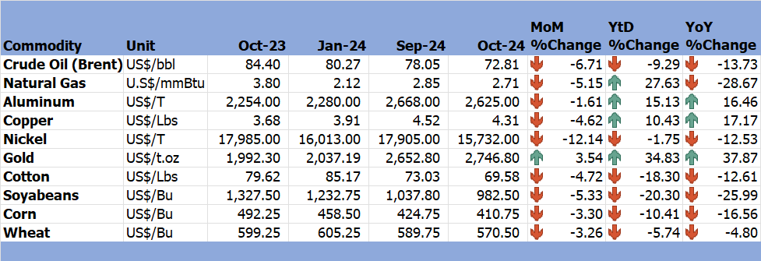

*Source: Trading Economics (2024)*

# 3.0 Zimbabwe GDP Growth Update

3.1 Zimbabwe GDP growth remain projected at 2% in 2024 amidst El-Nino induced drought effects which negatively affected the economy especially the agriculture and energy sector (Hydro-power station) subsequently impacting the industry sector.

# 4.0 Merchandise Trade Developments

4.1 Zimbabwe National Statistics Agency (ZimStat) had not published the merchandise trade data for October 2024 by the time of compiling this report, thus the analysis is based on August 2024 data.

4.2 Total merchandise trade amounted to USD1546.8 million in August 2024, up 12.8% from USD1371.5 million in July 2024 due to an increase in exports and imports. On a YoY basis, merchandise trade rose by about 5.2% from USD1469.9 million in August 2023 (RBZ August 2024 Monthly Review).

4.1 Although the trade deficit improved in August 2024 from July 2024, it still remains in the negative territory with a deficit of USD198.8 million (see Figure 2). Exports were USD674 million, 22.9% higher than in July 2024 and 3.7% higher than in August 2023 with the monthly increase being underpinned by growth in export earnings from gold, Platinum Group Metals (PGMs) and tobacco. Import bill amounted to USD872.8 million in August 2024, reflecting a 6% increase from July 2024 and 6.4% higher than in August 2023. Major imports in August 2024 were diesel, maize, petrol and machinery.

Figure 2: Merchandise Trade Developments

*Source: RBZ (2024)*

# 5.0 Exchange Rate Developments

## **5.1 ZWG Exchange Rate Developments**

5.1.1 The ZWG lost value against all major currencies on month on month (MoM), YtD and YoY basis as shown in Table 3 due to devaluation and to lack of public trust and confidence in the currency.

Table 3: ZWG Exchange Rate Movements - Month Ending 31 October 2024

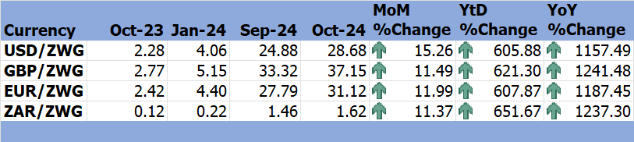

*Source: RBZ (2024)*

5.1.2 Strengthening of the ZWG remains fundamental to realizing the much-needed macroeconomic stability in the country. This calls for the need for the Reserve Bank to come up with measures to build public trust and confidence in the local currency.

## **5.2 Parallel Market Developments**

5.2.1 In October 2024, parallel market varied around USD/ZWG40 to 45 while official exchange rate fluctuated around USD/ZWG25.13 to 28.68 reducing parallel market premium from around 59% to around 57% (see Figure 3). The continued disparity between the two exchange rates points to lack of public trust and confidence in the local currency.

Figure 3 : Parallel Market Developments - October 2024

*Source: RBZ and Harare Streets (2024)*

## **5.3 Cross Rate Developments**

5.3.1 During the month under review, the USD gained value against the GBP, EUR and ZAR by 3.37%, 2.91% and 3.49% respectively, however, it lost against the GBP, EUR and ZAR on a YtD and YoY basis, see Table 4.

Table 4: USD Exchange Rate Movements – Month Ended 31 October 2024

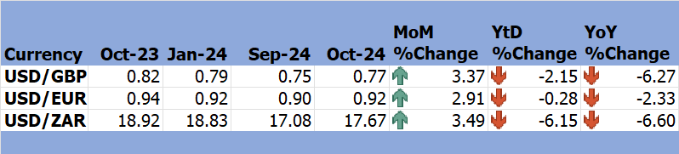

*Source: RBZ (2024)*

5.3.2 The appreciation of USD against the ZAR during the month, discourages the country’s exports to South Africa.

# 6.0 Inflation Developments

6.1 During the month under consideration, ZWG inflation rose from 5.8% in September 2024 to 37.2% in October 2024, see Figure 4. Since the introduction of the ZWG in April, the ZWG inflation has maintained an upward trajectory. This trend reflects the disparity in the official and parallel market exchange rates, supply chain disruptions due to geo-political conflicts and shortages due to El-Nino drought.

Figure 4: Month-on-Month ZWG Inflation Outturn

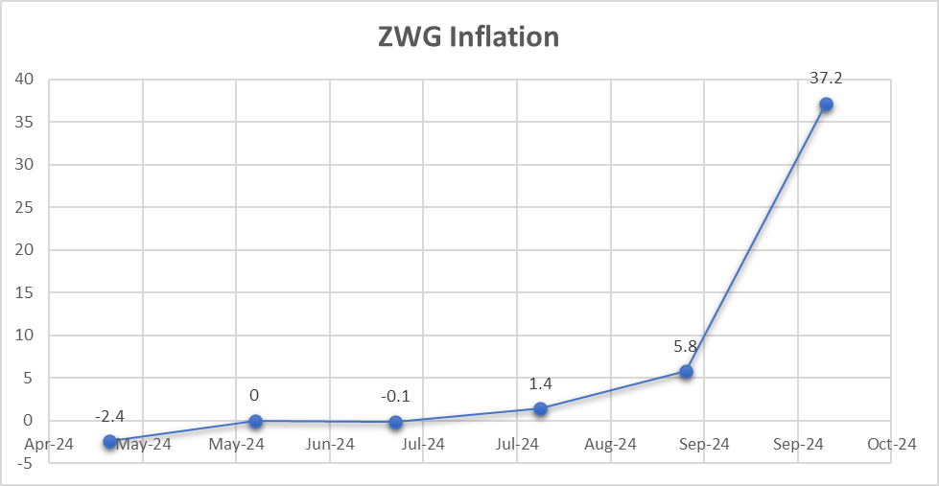

*Source: ZimStat (2024)*

6.2 MoM weighted inflation increased from 1.9% in September 2024 to 7.30% in October 2024 (see Figure 5).

Figure 5: Month-on-Month Weighted Inflation Outturn

*Source: ZimStat (2024)*

6.3 The main contributors to both weighted and ZWG inflation in October 2024 were food and non-alcoholic beverages and housing, water, electricity, gas and other fuels (see Table 5).

Table 5: Monthly Inflation for October 2024

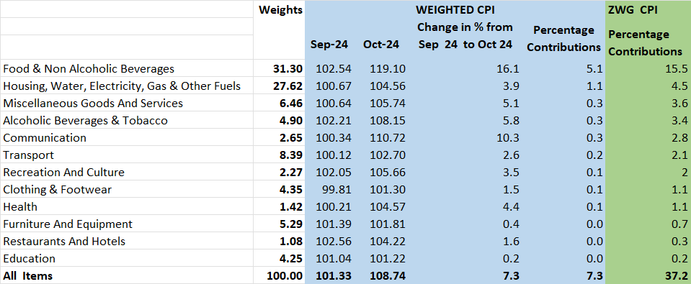

*Source: ZimStat (2024)*

# Monetary Developments

## **7.1 Money Supply**

7.1.1 By the time of compiling this report, October money supply statistics had not been published thus analysis in based on August 2024 data.

7.1.2 In August 2024, broad money stock stood at ZWG46.47 billion, a 1.08% growth from ZWG45.98 billion in July 2024 as shown in Figure 6 (RBZ August 2024 Monthly Economic Review). The money stock composed of foreign currency deposits of 74.68%, local currency deposits of 25.17% and 0.15% local currency in circulation.

Figure 6: Broad Money (M3) Supply

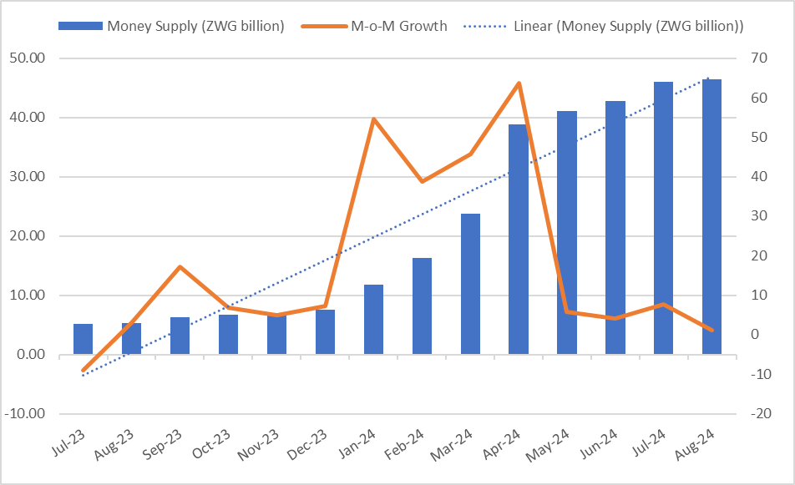

*Source: RBZ (2024)*

## **7.2 Interest Rates**

7.1.1 As of 11 October 2024, the average commercial bank deposit rate for savings on foreign currency was revised from a minimum of 1.53% to 1.22% and a maximum of 1.86% to 1.50%. Other categories of interest rates remained unchanged (refer to the NECF September 2024 Economic Bulletin).

7.1.2 The downward revision of the foreign currency saving interest rate discourages savings in foreign currency.

# 8.0 Stock Market Developments

## **8.1 Zimbabwe Stock Exchange**

8.1.1 The ZSE was characterized by bullish trend during the month under review mainly driven by gains in blue-chip stocks. On a MoM basis, the All Share Index, Top 10 Index, Value Traded, and Market Capitalization gained by gained by 18.79%, 17.64%, 1503.3%, and 20.05%, respectively. Value Traded growth was bolstered by strong performance across several key counters.

8.1.2 On year-to-date and year-on-year, all selected indices gained, see Table 7.

Table 6: Zimbabwe Stock Exchange Movements

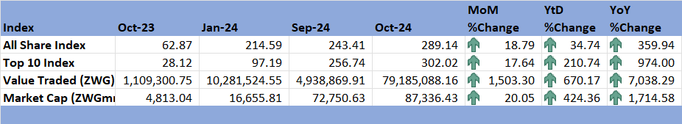

*Source: ZSE (2024)*

## **8.2 Victoria Falls Stock Exchange**

8.2.1 During the month under review, the VFEX market exhibited a bearish trend due to low activity. The All-Share index, Value Traded, and Market Capitalization lost by 2.79%, 74.89% and 3.61% respectively (see Table 8).

8.2.2 On a YtD basis the Value Traded and Market Capitalization retreated while the All Share Index gained by 0.16%. On a YoY basis, the All Share Index and Market Capitalisation gained by 51.78% and 9.08% respectively, while the Value Traded lost by 92.89%.

Table 7: Victoria Falls Stock Exchange Movements

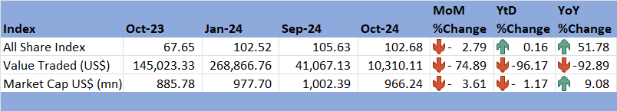

*Source: VFEX (2024)*

# 9.0 Recommendations

9.1 The following recommendations are being proposed:

**9.1.1 Enhancing Structural Reforms:** The country should prioritize structural reforms to boost productivity and resilience, particularly in agriculture and energy. This involves promoting investments in renewable energy and climate-smart agricultural practices to mitigate El Niño effects.

* + 1. **Diversification of Export Markets:** To mitigate the impact of global economic slowdowns, the country should diversify its export markets and products, focusing on high-demand commodities like gold, which has shown significant gains.

**9.1.3 Exchange Rate Stability:** Addressing the disparity between official and parallel market exchange rates is essential. This can be achieved by increasing market transparency, allowing for more flexible exchange rate policies, and boosting confidence in the local currency.

**9.1.4 Price Monitoring:** There is need to strengthen mechanisms to monitor and control inflationary pressures, especially in critical sectors like food and housing. This includes timely interventions to address supply chain disruptions and import dependencies.

* + 1. **Promote Savings in Local Currency:** To build confidence in the ZWG, the Reserve Bank should offer competitive interest rates for savings in local currency and strengthen financial literacy campaigns.

**9.1.6 Broad Money Supply Management:** The Reserve Bank should ensure that growth in money supply aligns with productive sector needs to avoid fuelling inflation.

**9.1.7 Boost Gold and PGM Production:** Given the favourable price trends for gold and platinum group metals (PGMs), Zimbabwe should enhance mining capacity and explore new markets.

**9.1.8 Reduce Fuel Import Costs:** There is need to take advantage of the declining global crude oil prices by negotiating long-term supply contracts to stabilize local fuel prices.

**9.1.9 Promote Export-Oriented Sectors:** Increase support for sectors contributing significantly to exports, such as agriculture (tobacco) and mining, through targeted incentives and infrastructure development.

**9.1.10 Import Substitution:** Invest in domestic production of major imports like maize and machinery to reduce the trade deficit and enhance local industries.

**9.1.11 Enhance Investor Confidence:** There is need to maintain a stable macroeconomic environment to attract both local and foreign investments into the ZSE and VFEX.

**9.1.12 Expand VFEX Listings:** There is need to encourage more companies to list on the VFEX to increase activity and diversify investment options.

**9.1.13 Climate-Resilient Policies:** The government should develop and implement comprehensive policies to mitigate climate change impacts, especially targeting the agriculture and energy sectors.

# 10.0 References

ALJAZEERA. (2024, October 24). *Business and Economy*. Retrieved from Al Jazeera: https://www.aljazeera.com/news/2024/10/24/zimbabwes-gold-backed-currency-loses-half-its-value-why-and-whats-next

IMF. (2024). *World Economic Outlook, October 2024; Global Prospects and Policies.* International Monetary Fund.

RBZ. (2024). *Exchange Rates*. Retrieved from Reserve Bank of Zimbabwe: https://www.rbz.co.zw/index.php/research/markets/exchange-rates

Reserve Bank of Zimbabwe. (2024). *Monthly Economic Review: August 2024.* RBZ.

Reserve Bank of Zimbabwe. (2024). *Weekely Economic Highlights, 11 October 2024, Vol 26 No 41.* Reserve Bank of Zimbabwe.

Trading Economics. (2024). *Commodities*. Retrieved from Trading Economics: https://tradingeconomics.com/commodity/crude-oil

VFEX. (2024). *Main Dashboard*. Retrieved from Victoria Falls Stock Exchange: https://www.vfex.exchange/

World Bank. (2024). *October 2024 Commodity Markets Outlook.* World Bank Group.

ZimStat. (2024). *Inflation Rates*. Retrieved from Zimbabwe Statistics Agency: https://www.zimstat.co.zw/

ZSE. (2024). *Main Dashboard*. Retrieved from Zimbabwe Stock Exchange: https://www.zse.co.zw/

**NECF Secretariat, 2024**